**Practical no.-**14

**Title:** Develop a program to implement List View, Grid View,Image View and Scroll View.

**Roll No.:**15 **Batch-** A **Date of Performance:** 22/02/2024

**activity_main.xml**

<?xml version="1.0" encoding="utf-8"?>

<ScrollView xmlns:android="http://schemas.android.com/apk/res/android"

xmlns:app="http://schemas.android.com/apk/res-auto"

xmlns:tools="http://schemas.android.com/tools"

android:layout_width="match_parent"

android:layout_height="match_parent"

tools:context=".MainActivity">

<LinearLayout

android:layout_width="match_parent"

android:layout_height="match_parent">

<ListView

android:id="@+id/lst"

android:layout_width="356dp"

android:layout_height="633dp" />

</LinearLayout>

</ScrollView>

**MainActivity.java**

package com.example.a141listview;

import androidx.appcompat.R.layout;

import androidx.appcompat.app.AppCompatActivity;

import android.annotation.SuppressLint;

import android.os.*;

import android.widget.*;

import android.view.*;

public class MainActivity extends AppCompatActivity {

ListView lst;

@SuppressLint("MissingInflatedId")

@Override

protected void onCreate(Bundle savedInstanceState) {

super.onCreate(savedInstanceState);

setContentView(R.layout.activity_main);

lst=(ListView) findViewById(R.id.lst);

String lang[]={"Android","Java","Php","Hadoop","Sap","Python" ,"Ajax", "C++", "Ruby","Rails", "JavaScript","C#",

"Swift", "Go","TypeScript", "Kotlin", "Rust", "Perl", "Scala", "HTML/CSS", "Objective-C", "SQL", "Shell",

"Assembly", "R", "MATLAB", "Lua", "Dart", "Haskell", "Julia", "Groovy", "Visual Basic", "Clojure", "F#", "Elixir"

};

ArrayAdapter ad =new ArrayAdapter(MainActivity.this,android.R.layout.simple_spinner_dropdown_item,lang);

lst.setAdapter(ad);

lst.setOnItemClickListener(new AdapterView.OnItemClickListener() {

@Override

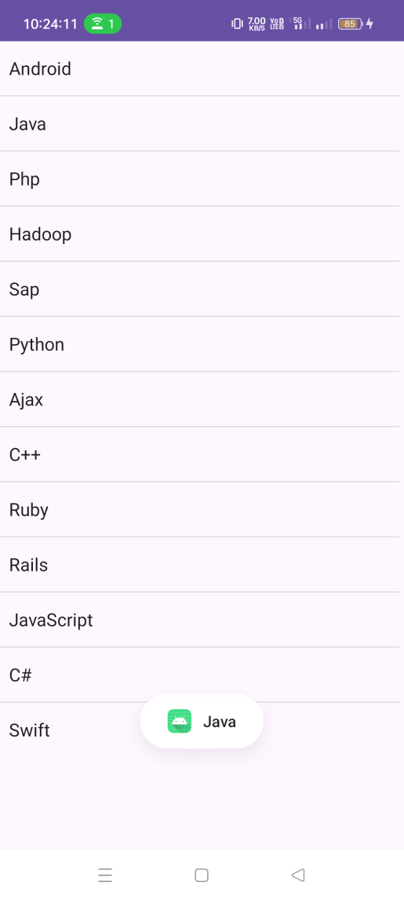 public void onItemClick(AdapterView<?> parent, View view, int position, long id) {

Toast.makeText(MainActivity.this,lang[position],Toast.LENGTH_SHORT).show();

}

});

}

}

**activity_main.xml**

<?xml version="1.0" encoding="utf-8"?>

<RelativeLayout xmlns:android="http://schemas.android.com/apk/res/android"

xmlns:tools="http://schemas.android.com/tools"

android:layout_width="match_parent"

android:layout_height="match_parent"

tools:context=".MainActivity">

<GridView

android:id="@+id/gridView"

android:layout_width="match_parent"

android:layout_height="match_parent"

android:numColumns="3"

android:columnWidth="100dp"

android:verticalSpacing="10dp"

android:horizontalSpacing="10dp"

android:padding="10dp"

android:gravity="center"/>

</RelativeLayout>

**MainActivity.java**

package com.example.a143grid;

import android.os.Bundle;

import android.view.View;

import android.view.ViewGroup;

import android.widget.AdapterView;

import android.widget.ArrayAdapter;

import android.widget.Button;

import android.widget.GridView;

import android.widget.Toast;

import androidx.appcompat.app.AppCompatActivity;

import java.util.ArrayList;

import java.util.List;

public class MainActivity extends AppCompatActivity {

GridView gridView;

List<Button> buttons;

@Override

protected void onCreate(Bundle savedInstanceState) {

super.onCreate(savedInstanceState);

setContentView(R.layout.activity_main);

gridView = findViewById(R.id.gridView);

buttons = new ArrayList<>();

for (int i = 0; i < 15; i++) {

Button button = new Button(this);

button.setText("Button " + (i + 1));

buttons.add(button);

}

ButtonAdapter adapter = new ButtonAdapter(buttons);

gridView.setAdapter(adapter);

gridView.setOnItemClickListener(new AdapterView.OnItemClickListener() {

@Override

public void onItemClick(AdapterView<?> parent, View view, int position, long id) {

Toast.makeText(MainActivity.this, "Button " + (position + 1) + " clicked", Toast.LENGTH_SHORT).show();

}

});

}

private class ButtonAdapter extends ArrayAdapter<Button> {

ButtonAdapter(List<Button> buttons) {

super(MainActivity.this, 0, buttons);

}

@Override

public View getView(int position, View convertView, ViewGroup parent) {

Button button = buttons.get(position);

button.setFocusable(false);

button.setClickable(false);

return button;

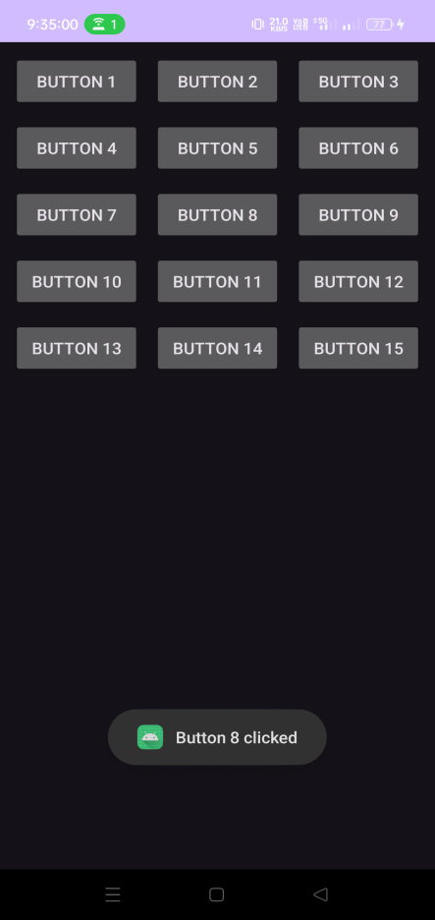 }

}

}

**activity_main.xml**

<?xml version="1.0" encoding="utf-8"?>

<LinearLayout xmlns:android="http://schemas.android.com/apk/res/android"

xmlns:tools="http://schemas.android.com/tools"

android:layout_width="match_parent"

android:layout_height="match_parent"

android:orientation="vertical"

tools:context=".MainActivity">

<ScrollView

android:layout_width="340dp"

android:layout_height="match_parent">

<TextView

android:id="@+id/textView"

android:layout_width="wrap_content"

android:layout_height="wrap_content"

android:text=" Lorem ipsum dolor sit amet, consectetur adipiscing elit. Sed sollicitudin dolor a felis congue, sed molestie quam venenatis. Nulla facilisi. Proin nec nibh nec metus viverra consequat. Integer eget odio a justo tristique posuere. Fusce ac libero quam. Donec bibendum in velit eu finibus. Suspendisse potenti. Pellentesque habitant morbi tristique senectus et netus et malesuada fames ac turpis egestas. Vestibulum ante ipsum primis in faucibus orci luctus et ultrices posuere cubilia curae; Duis sit amet risus ex. Morbi vitae arcu vitae magna sodales varius. Integer varius odio vel posuere auctor. Vestibulum sed libero est. Sed in consequat dui. Donec tincidunt sapien ut velit bibendum, nec volutpat sapien viverra. Ut sit amet tincidunt ligula."

android:textSize="40dp" />

</ScrollView>

</LinearLayout>

**MainActivity.java**

package com.example.a144textview;

import androidx.appcompat.app.AppCompatActivity;

import android.os.Bundle;

public class MainActivity extends AppCompatActivity {

@Override

protected void onCreate(Bundle savedInstanceState) {

super.onCreate(savedInstanceState);

setContentView(R.layout.activity_main);

}

}



1. **Output**

